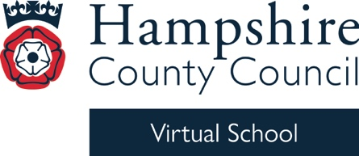


Virtual School Update 9

Extended Duties
Annual Adoption Barometer Survey

The annual Adoption Barometer survey is live. The survey is shorter this year and takes just 10 minutes. Please share with families or young people aged 16 or over who are adoptees, an adoptive parent of a child aged 0-25, or those involved in adoption approvals or matching during 2024. This is an opportunity to share views on a wide range of issues, from preparing to adopt to finding adoption support, from school to employment, and from accessing records to relationships with the birth family.
With thousands of respondents every year, Adoption UK’s Adoption Barometer is the UK’s only comprehensive take on how policy and practice impact the lives of those affected by it. Now in its 8th year, the Barometer has the attention of governments and adoption agencies across the UK.
Complete the Adoption Barometer 2026 survey here: https://www.surveymonkey.com/r/AdoptionBarometer2026.
Find out more about the Adoption Barometer here: www.adoptionuk.org/the-adoption-barometer.

Training

ARC events (These are external webinars led by schools that are members of ARC)

Kind regards

Michelle

Michelle Nye
Virtual School Head
Hampshire Virtual School

