


Virtual School Update 15

Dear Designated Teacher and Lead

I hope this update finds you well. Attached is the termly newsletter that was shared via School Comms last week, in case you missed it.

This update also includes details of useful documentation that has recently been refreshed on Moodle, along with a helpful visual resource shared by Anthony Benedict on LinkedIn which serves as a timely reminder and reflection tool.

In addition, we would like to highlight the Healing Spaces training (details attached) and an ARC webinar hosted by Rowhill School: Opening Doors: Our Journey to a Restorative, Trauma-Informed School. This promises to be a valuable session and we strongly encourage you to book a place.

Finally, our upcoming training sessions are listed below. Please note that three sessions are taking place this week. If you were unable to book before the deadline and the link has expired, please contact HCC.VSTraining@hants.gov.uk.

For action
- The PEP deadline for this term is Friday 3 July, so please make sure that PEP meetings are booked in. If there is a problem with your login or you need access for someone else, please get in touch by emailing the PEP inbox: HCC.PEPs@hants.gov.uk.
- If your DT has changed, please notify us to ensure we have the most up-to-date information: virtualschool@hants.gov.uk.

Moodle

We have added the following documents to the Virtual School Moodle:

- Transfer of Records for Children with a Social Worker Ever 6
This guidance outlines how information should be shared when children with a social worker (CWSW) or CWSW Ever 6 move between education settings

- Previously Looked-After Children Information Sharing for Schools
This guidance explains how schools should manage information about a child’s previously looked after or adopted status with care and confidentiality

- Previously Looked-After Children Information Sharing Template for School Enrolment Forms
This document is intended for schools to publish on their website to help parents and carers of previously looked-after children understand the benefits of sharing their child’s adoptive, special guardianship order or child arrangements order status

All three documents can be found here: Course: Policies and Guidance | Hampshire Virtual School.

In addition, the CWSW document is also located under Course: Children with a Social Worker (CWSW) | Hampshire Virtual School, and the two PLAC documents can be found under Course: Previously Looked-After Children (PLAC) | Hampshire Virtual School.

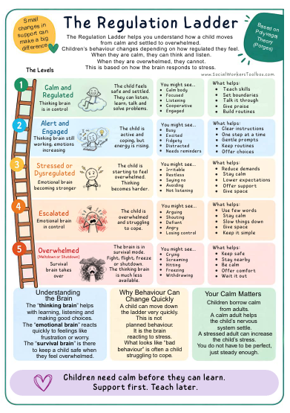

The Regulation Ladder

Please follow this link to access the Regulation Ladder, which helps explain how a
child can move from calm and settled to overwhelmed. There are also more downloadable resources available on www.socialworkerstoolbox.com

ARC webinar presented by Rowhill School – Opening Doors: Our Journey to a Restorative, Trauma-Informed School

Join Hampshire Virtual School and Rowhill School as they reflect on Rowhill's determined journey to review, rebuild and reframe relationships and culture.

Matt Poole, Assistant Headteacher, explains how one of the most transformative steps they have taken has been the introduction of restorative and relational practice, underpinned by a trauma-informed approach. Here he explains how this approach has improved behaviour and outcomes.

This session will be held on Thursday 14 May, from 3.45pm to 4.45pm.

Click here to book.

International Rescue Committee – Healing Spaces Session
This in-person training will be held on Wednesday 29 April and is aimed at anyone who works with refugee children and young people. The session will provide an introduction to trauma-informed approaches, a review of the trauma-informed framework with case studies to demonstrate how it can be implemented in real-life situations, and techniques and strategies to support people dealing with potential trauma.

The training, which is free to attend, is hosted by Hampshire Virtual School and delivered by the International Rescue Committee.

Please see the attached flyer for more information and to register for the session.

Training

ARC events (these are external webinars led by schools that are members of ARC).

Kind regards

Michelle

Michelle Nye
Virtual School Head
Hampshire Virtual School

