


Virtual School Update 17

Dear Designated Teacher and Lead

I hope you had a wonderful half-term break and were able to manage the recent heat!

We are pleased to share an exciting opportunity for secondary schools to take part in our Executive Functioning Project. Further details are outlined below and in the attached information. In addition, Bosmere Primary School will be hosting an ARC webinar later this month on Developing Executive Functioning Skills as Part of a Relational Approach – registration details are included below.

We have also highlighted a range of upcoming training sessions which may be of interest. If a session is scheduled for this week and booking links are no longer active, please contact the Virtual School Training Inbox at HCC.VSTraining@hants.gov.uk and we will ensure you receive the joining details. Please also share these training opportunities widely within your school.

Finally, a reminder that consultations with our Educational Psychologist, Felicity Ang, are available. Further information, including upcoming dates until the end of term, can be found here: Educational Psychologist consultations | Education and learning | Hampshire County Council.

For action

- PEP completion: please ensure that PEP meetings are booked with social workers. If there is a problem with your login or you need access for someone else, please email the PEP inbox: HCC.PEPs@hants.gov.uk. The deadline for completed PEPs this term is Friday 3 July. If you have any questions, please let us know. PEP exemplars are available within the Asset system.
- Please select ‘complete’ once you have finished each module, or you may not receive PEP funding for that term.

Executive functioning project ​opportunity for secondary schools

The Virtual School is offering a limited number of Hampshire secondary schools an opportunity to take part in an executive functioning project for 2026-2027.

As part of this offer, schools will receive training on executive functioning, along with ongoing coaching and access to resources to support auditing and implementation.​ There will also be an opportunity, in summer 2027, for schools to showcase the impact of the project and share good practice.

​Please see the attached flyer for full details.

ARC webinar presented by Bosmere Junior School: Developing Executive Functioning Skills as part of a Relational Approach

Join Hampshire Virtual School and Bosmere Junior School as they reflect on Bosmere's journey to embed their whole school, relational approach and meeting the needs of vulnerable learners through the development of children's executive functioning skills.

This session will be held on 30 June 2026, 3.45pm to 4.45pm.

To book, please follow this link:

https://www.eventbrite.co.uk/e/1987612497485?aff=oddtdtcreator

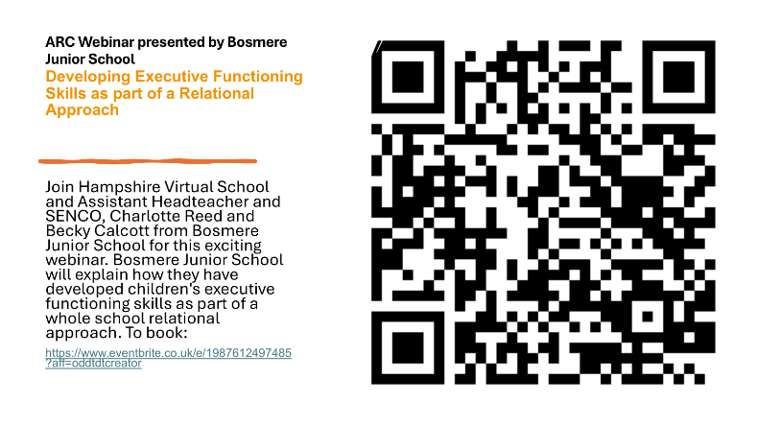

Training

Writing an Effective PEP – Including Needs Analysis Tools, online training.

9 June 2026, 9.30am to 11.30am.

Click here to book.

Promoting the Education of CWSW, online training.

10 June 2026, 9.30am to 11.30am.

Click here to book.

Early Years: Writing an Effective PEP, online training.

10 June 2026, 9.30am to 12pm.

Click here to book.

Gathering Child Voice online training.
16 June 2026, 3.45pm to 5pm.

Click here to book.

Early Years: Emotion Coaching, online training.

18 June 2026, 9.30am to 11am.

Click here to book.

ARC events (these are external webinars led by schools that are members of ARC).

ARC Primary Phase Network, online webinar.
4 June 2026, 4pm to 5pm.

Click here to book.

Emotionally Intelligent Classrooms: Understanding SEMH Behaviour, online webinar.
9 June 2026, 2.30pm to 3.30pm.

Click here to book.

Kind regards

Michelle

Michelle Nye
Virtual School Head
Hampshire Virtual School

