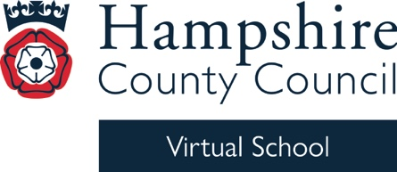


Virtual School Update 18

Dear Designated Teacher and Lead

I hope this update finds you well. Below are details about the upcoming South East ARC Conference, as well as an offer from Adopt South for our adoptive families. Really exciting news: Hampshire Virtual School have been shortlisted for an ARC award. I will let you know after 9 July whether we have been successful!🤞🏻

We still have a number of training sessions on offer this term. Gathering Child Voice and Early Years: Emotion Coaching are taking place this week. If you are unable to book before the deadline and the link has expired, please contact HCC.VSTraining@hants.gov.uk to request a place.

Our training brochure for next year has just been finalised and is attached. You will also find the new version on our website. Within the brochure, you will find details of next year’s DT conference, which will be held on Thursday 5 November. We have two great keynote speakers, Jaz Ampaw-Farr and Steven Russell, both of whom I heard speak at our National Conference.

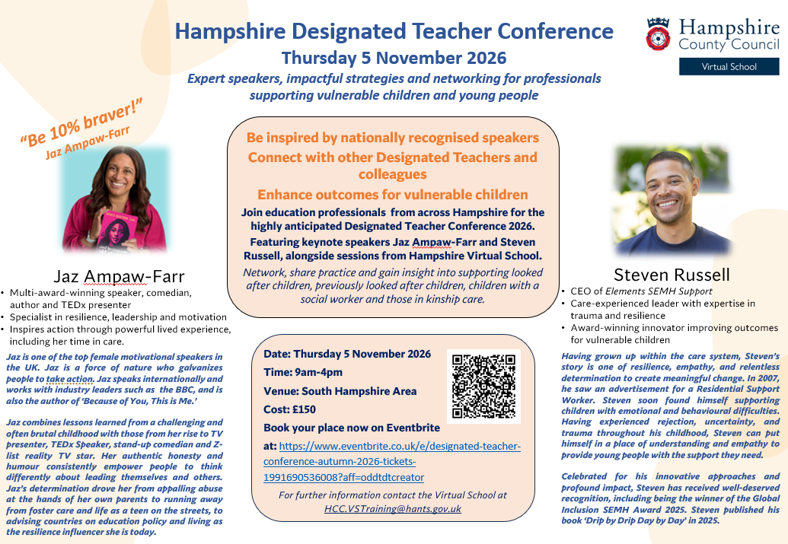

For action

- PEP completion: please ensure that PEP meetings are booked with social workers. If there is a problem with your login or you need access for someone else, please email the PEP inbox: HCC.PEPs@hants.gov.uk. The deadline for completed PEPs this term is Friday 3 July. If you have any questions, please let us know. PEP exemplars are available within the Asset system.
- Please select ‘complete’ once you have finished each module, or you may not receive PEP funding for that term.

London and South East ARC Conference
I am pleased to share the latest flyer for the London and South East Regional Conference: Engagement and Relationships – Meeting the Needs of Our Children and Young People, taking place on Thursday 9 July 2026, from 9am to 4pm in London.

We are really pleased that Tim Woodford, Headteacher and Helen Hannam, Deputy Headteacher at Rownhams St John’s CE Primary School will be delivering a workshop.

Adopt South – support for adoptive families:

We are pleased to share some information from Adopt South, the Regional Adoption Agency for Hampshire, the Isle of Wight, Portsmouth and Southampton, which may be helpful for you and the adopted children and families you support.

Adopt South provides a comprehensive adoption support offer for adoptive families, including workshops, courses and informal social opportunities for parents and young people. Please see the attached Calendar of Events, which outlines upcoming sessions available to parents at no cost.

We have also attached information about the Adopt South Catch Up Call service, which is available to parents as part of their Adoption Support Offer. These provide adoptive parents time to reflect, ask questions and receive guidance from an experienced practitioner.

In addition, you may wish to be aware of the Empowering Parents course, designed for parents of adopted children who have experienced trauma, neglect or disruption in early caregiving relationships. The programme is informed by Dyadic Developmental Practice (DDP) and focuses on developing an attitude of Playfulness, Acceptance, Curiosity and Empathy (PACE). The next course begins in September 2026 and runs for 12 weeks (term time only).

- Endorsed by the Dyadic Developmental Psychotherapy Institute (DDPI)
- Delivered by qualified facilitators trained to DDP Level 1 as a minimum
- Includes collaborative group activities and shared learning with other parents
- Free to attend, with no impact on any current or future Adoption and Special Guardianship Support Fund (ASGSF) therapeutic applications

Adoptive parents who wish to find out more about this course can complete this form to receive further information from Adopt South.

We hope this information is helpful and can be shared with families where appropriate.

Training

Gathering Child Voice online training.
16 June 2026, 3.45pm to 5pm.

Click here to book.

Early Years: Emotion Coaching, online training.

18 June 2026, 9.30am to 11am.

Click here to book.

Designated Teacher Training, face-to-face training.

23 June 2026, 9.30am to 4pm.

Click here to book.

ARC Webinar - Bosmere Junior School

30 June 2026, 3.45pm to 4.45pm.

Click here to book.

Kind regards
Michelle

Michelle Nye
Virtual School Head
Hampshire Virtual School

