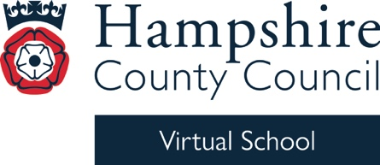


Supporting children with a social worker in schools
An executive functioning pilot project at Park Community School
Contents

Introduction 3
Executive functioning and Children with a Social Worker 6
Park Community School executive functioning project 10
Impact of the project 17

Introduction

Supporting children with a social worker in schools: a pilot project focusing on executive functioning at Park Community School
An action-research project initiated by Hampshire’s Virtual School about supporting children with a social worker (CWSW) in school has become an exciting collaboration between Hampshire and school teams that shows very promising impact.

Tamsin Austoni, Deputy Head of Service at the Virtual School, brought together colleagues from the Hampshire SEND and Inclusion team, Hampshire Improvement and Advisory Service (HIAS) and a team from Park Community School to look closely at the issues facing CWSW in school and explore approaches to supporting these children in an efficient way that benefits a wide range of students.

Why focus on children with a social worker?

Using the Hampshire and IOW Safeguarding Children Partnership thresholds chart, it is easy to see why CWSW would be vulnerable in education: the bar for Social Services involvement with children and families is set high, meaning that children who have a social worker have “a high level of unmet and complex needs” or are “in need of protection” from a range of situations including – but not limited to – the suspicion of physical, emotional or sexual abuse, neglect, domestic violence, extreme poverty, homelessness, the risk of radicalisation, offending or antisocial behaviour or breakdown of family relationships.

It stands to reason that children experiencing such a high level of complex and difficult circumstances are likely to struggle with a range of different aspects of school life. Attendance and engagement at school are protective factors for vulnerable children, but it also stands to reason that these children need more support than their peers to manage within the structures of school life. Statistics for children with a social worker show that they are disproportionately represented among the groups of children who have low attendance at school, who are withdrawn from lessons, who are sanctioned for behaviour, who struggle with punctuality, who are excluded from school and who struggle with academic achievement. The Virtual School has responsibility for promoting the education of CWSW, and the aim of the project has been to find ways that schools can support these students to attend school, engage and achieve.

Why base the work in Park Community School?

The team at Park Community School are always looking for ways to improve and extend their practice in order to empower, inspire and meet the needs of their students. The school’s vision sets out its goal as “Success for all through attainment, resilience and autonomy,” very much the areas on which CWSW have to work even harder than their peers to cope successfully in education.

Park Community School has a significant number of children who have had involvement with a social worker at some point in their lives – the Virtual School was able to share with the school that close to a quarter of students have had some involvement with social services in the previous 6 years.

One of the challenges for any school in supporting children with social workers is that schools are not always notified when there is a social care intervention: social workers operate under strict confidentiality rules and some information about a child’s social services involvement is only shared on a need-to-know basis. Schools – and certainly classroom teachers – may not be informed unless there is a safeguarding concern that directly affects the school environment or the child’s education. Information about past social services involvement may not be passed on during transition from primary school.

Without being certain that teachers can always know exactly which children have had involvement with a social worker, or when, or for what reason, the school recognised the importance of developing practice that will support all children effectively, aiming to meet the needs of children who have had a social worker through an holistic approach designed around the aspects of school life that research suggests are likely to be a challenge for these students.

Why focus on executive functioning?

Children who are currently involved with social services may well be at a crisis point within their lives, while children who have previously had social services support may be at a more stable point in their lives but have learning gaps or lasting after-effects from earlier periods of difficulty. Trauma and adverse childhood experiences have profound implications for neurodevelopment, and the after-effects of trauma include neurobiological changes that negatively affect the development of executive function – and executive functioning is crucial for coping and thriving in school.

Issues around the development of executive function sit at the intersection between trauma and neurodiversity, so strategies that consciously support children to develop executive functioning are likely to be useful not only for children with a social worker, but a wide range of neurodiverse children, including those with Autism and Attention Deficit Hyperactivity Disorder (ADHD). Both trauma-informed practice and neurodiversity-informed practice recommend a range of similar approaches.

Research also shows that young people of lower socio-economic status have a greater risk of poor executive function development compared to higher income counterparts within their own country, suggesting that approaches that focus on supporting the development of executive function is also likely to be beneficial for students experiencing economic disadvantage.

Executive functioning and CWSW

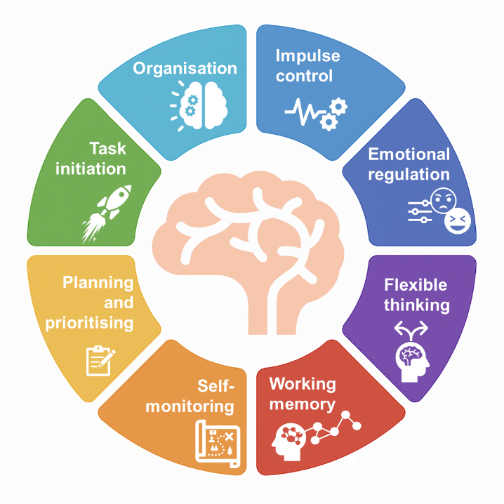
What is executive functioning?

Executive functioning refers to the set of mental skills that help individuals manage their thoughts, actions and emotions to achieve their goals. These are primarily skills in prioritising, organising, problem-solving and self-regulating, and their development is not usually complete until we are about twenty-five years old – although many older adults feel that, at times, they also struggle with some of these areas.

Imagine executive functions as the rider guiding a spirited horse. The horse represents a child’s instinctive impulses and emotional reactions – powerful and fast, but not always predictable. At first, the rider has limited control, relying on basic cues to keep the horse from bolting. Over time, as the rider gains skill and strength, they can steer with precision, adjusting speed and direction to navigate complex terrain. Just as in learning to ride a horse, children need skilled instruction and modelling in executive functioning to help them learn to regulate impulses, plan ahead, and adapt their behaviour to meet goals.
Executive functioning wheel graphic adapted from https://addvantageslearningcenter.com/executive-functioning/

Executive functions are important for everyone and are integral to the smooth running of school life. School makes significant demands on students’ executive functioning skills every day, and recognising the challenges faced by students whose executive functioning development has been disrupted or delayed is the first step in supporting these students.

The key areas of executive function are:
- Impulse control – thinking before acting; the ability to resist distractions, impulses or inappropriate responses
- Emotional regulation – awareness of emotions and the ability to manage emotional responses
- Flexible thinking – being able to adapt to the unexpected or to changes
- Working memory – the ability to hold information in mind in order to follow instructions, understand explanations or complete tasks
- Self-monitoring – awareness of how one is doing in the moment
- Planning and prioritising – working out how to meet goals
- Organisation – keeping track of things mentally and physically
- Task initiation – taking action to get started on tasks.
What happens if executive function development is delayed or disrupted?

Because executive functioning naturally develops over time until we are around 25 years old, it roughly equates with our understanding of maturity, as opposed to intelligence. US academic Russell Barkley, PhD, a recognised authority on ADHD and executive functioning, notes that adults working with children and teens with ADHD should mentally calculate for a 30% delay in executive function development, i.e. that a child of ten with ADHD is likely to have the impulse control, self-regulation and organisational skills of a seven-year-old, and a sixteen-year-old is likely to have an “executive function age”, as Barkley calls it, of about eleven.

Although Barkley has published extensive research on executive functioning, he describes this 30% figure as based on his “review of studies and [his] distillation of that research” into an easily understood and valuable concept, rather than the result of a specific study. While Barkley’s research specifically relates to ADHD rather than trauma or adverse childhood experiences, this quick mental calculation can be useful for teachers in thinking about the needs of the range of children in the classroom, catering for all by anticipating what systems and support in terms of executive functioning would make the content and expectations of the lesson accessible for the children most vulnerable to difficulties with executive function, including children with a social worker.

Kathleen Knight Barrett, a specialist executive functioning coach, builds upon Barkley’s influential research and his model of a 30% developmental delay in executive functioning, emphasizing that deficits in executive processes – such as planning, working memory, and emotional control – underpin functional impairments, and advocating for interventions that strengthen these skills to improve outcomes for children who struggle with these areas.

“Setting expectations that match the appropriate developmental age of a child, as opposed to her chronological age, results in meeting the child where she is rather than place unrealistic expectations upon her. This is typically where the level of anxiety, overwhelm, or depression may increase if there are no supportive adults in the child’s life such as therapists, coaches, teachers, parents, or other caregivers. At stages of increased independence and workloads, the impairment in executive function can be more visible with respect to behavior and self-determination levels of the student.”

While executive functioning for children in primary school is often supported by the single-classroom environment and the involvement of additional adults, transition to secondary school can present a range of challenges to executive functioning for all children, and especially for those who already face difficulties in this area.

Children and teens whose executive function development is delayed or hindered can present in the classroom and around school as poorly behaved, especially when task initiation, impulse control or emotional regulation are particular challenges, and difficulties with organisation, planning and prioritisation can easily translate into lateness, wandering the corridors, lack of appropriate equipment and lack of homework. The flexible thinking and self-monitoring required in school to meet the expectations of different classrooms, make transitions between tasks, switch attention on demand and consider how to improve – either in terms of behaviour or study – can, when this is a less developed area, lead to rigid behaviours, distraction, frustration, unhealthy habits and lack of self-care.

Area of executive functioning | What struggles in this area might look like in school
Planning & Prioritising | - Avoiding tasks perceived as too challenging  - Running out of time because of slow work or distraction  - Struggling to balance social demands and work  - Finding it hard to break tasks down into manageable steps  - Starting work without thinking it through and therefore going wrong/having to restart tasks
Organisation | - Finding it difficult to organise equipment/school bag or arriving without required equipment  - Difficulty managing homework  - Struggling to organise ideas (eg completing tables, grouping or sequencing information, spotting patterns and connections, keeping work in order in exercise books)
Flexible Thinking | - Struggles with moving from one activity or lesson to another  - Unsettled by change  - Difficulties in unstructured times of the day  - Unable to move on from playground disputes  - Finding it difficult to see another point of view  - Difficulty in transferring skills
Task Initiation | - Difficulties getting started on tasks without intervention  - Lacks problem solving skills/strategies  - Apparent avoidance or off-task behaviour  - Apparent daydreaming
Working Memory | - Unable to remember multi-step instructions  - Finding it difficult to hold in mind information to complete a task
Self-Monitoring | - Do not see their behaviour in the same way as others – not recognising how it might affect others  - Often make mistakes in their work and do not check over work  - Unable to understand why work is graded poorly and perceive it as unfair treatment  - Finding it difficult to keep track of time and progress
Impulse Control | - Unable to wait for feedback/gratification  - Easily distracted/fidgety  - Sensory-seeking behaviour or a need for comfort  - Difficulty taking turns/talks over others/calling out in class
Emotional Control | - Difficulties self-regulating emotions – outbursts or meltdowns  - Becoming overwhelmed or anxious  - Difficulties with peers/social skills  - Overreacting to unseen triggers – being misunderstood by others

Why are children with a social worker particularly vulnerable to the impact of executive function challenges?

Any and all of the issues linked to delayed development of executive function can mean that these young people may very frequently be faced with negative interactions with the adults who must maintain high expectations and manage complex groups with a variety of needs in a school setting. The child’s self-image becomes one of a person who does not do well in school, which can lead them to avoid or reject school – a crucial protective factor for young people who are socially vulnerable. CWSW need to feel a sense of belonging and to experience regular positive interactions with adults in school, just as their peers do.

Children with delays in executive functioning whose parents are fully engaged in supporting them and have the resources to advocate for them are protected from the worst impact of the challenges they face – parents play a huge role in supporting a child to develop their executive functioning by co-regulating with the child and providing the organisational framework of their lives. When a child or young person is involved with social services, it is likely that at least part of the reason is that their parents are unable to provide this framework in a consistent way: the children who need the most support often live within a family situation where this support is least available from home.

Most adults can provide anecdotal examples of times in their lives when aspects of their own executive functioning have been adversely affected by stressors: the sudden increase in cognitive demand of caring for a new baby hitting the ability to plan and prioritise, for example, or the emotional impact of a bereavement hitting the ability to self-monitor and initiate tasks, or the stress of moving house hitting the ability to maintain emotional control, and so on. Involvement with social services reflects the fact that the child and/or their family are already facing significant stress, and although social worker involvement provides support, it can be stressful in itself.

Park Community School project

Having agreed to provide the school setting for this executive functioning project, Ella Capaldi, the Head of School, offered the opportunity to teachers to take the lead from the school side and to work with colleagues from the Virtual School, HIAS and the SEND and Inclusion team. Three teachers – Jack Banting (English), Alice Nuttall (MFL) and a member of the history department who has since left the school – participated in the project from the beginning, reflecting on and adapting their own practice and delivering training to colleagues.

Project steps | Who was involved | Focus
Project launch and initial training | Virtual School  HIAS  SEND and Inclusion team  Park Community team | - Executive functioning and CWSW  - Executive functioning in the secondary classroom  - Trauma and its effects on child development
Learning walks including lesson study | Virtual School  HIAS  SEND and Inclusion team  Park Community team | - Executive functioning demands of lessons  - CWSW responses in the classroom and around school
Project planning | Virtual School  HIAS  SEND and Inclusion team  Park Community team | - Round table discussion and project planning  - Sharing resources and research materials
In-school development work | Park Community team | - Staff and student surveys  - Whole staff CPD on executive function  - Executive function resources developed for student planner
Explicit teaching about executive function at KS3 | Park Community team  SEND and Inclusion team | - Executive function lesson plans developed from resources shared by the SEND and Inclusion team and delivered to KS3 classes
Interventions for vulnerable children | SEND and Inclusion team  Park Community team | - 1:1 support for students identified by the school as needing intervention to develop executive functioning delivered by the SEND and Inclusion team  - Follow-up support and implementation of adaptations by Park Community SEN team
Monitoring | HIAS  Virtual School  SEND and Inclusion team  Park Community team | - Reflections on impact of ongoing CPD programme on teacher practice  - Review of key indicator data (attendance, behaviour referrals, suspensions)  - Considerations of how to adapt and sustain the approach in school without involvement of external agencies

Observations in classrooms

One of the early stages of the project was to carry out a series of observations within the project teachers’ lessons focusing on the experiences and responses of children with a social worker through the lens of executive function: we considered the demands on different aspects of executive functioning during normal lessons and observed the responses of these particular students.

Observers from HIAS, the Virtual School and the SEND and Inclusion team each took responsibility for observing a particular focus: the actions of the teacher, the response of rest of the class and the responses of the focus child/children for a timed observation, making notes minute-by-minute for later comparison and analysis.

We observed students clearly struggling with impulse control, particularly related to sensory stimuli; we saw hypervigilance having a cumulative effect on one student, whose attention was grabbed every time there was a movement outside the window in the classroom door, slightly behind where they were sitting but just about within their field of vision. This meant that the student struggled increasingly throughout the lesson to remember information that had been shared or the steps within instructions, although they had been coping well with the expectations of learning earlier on within the lesson.

We observed several of the students struggling with task initiation across a range of subjects; most needed one-to-one support to talk through the tasks before being able to get going. This was partly to do with organisation of resources, as there were several occasions when students did not have what they needed for the lesson, or did have the materials but had not put them out on their desks and had to search through their bags following a prompt from an adult. Finding previous work in their exercise book was difficult for one student, even though they had completed the task, because they had moved on a few pages and written the work in the wrong place and then gone back to fill in the gaps.

We saw straightforward strategies already in use by teachers to support students’ working memory and self-monitoring: timers built into lesson resources; visual reminders of task steps left on show on whiteboards; lists of resources needed for lessons on classroom walls. We also saw interpersonal support, including calm interactions with a student who was struggling with emotional control because they were feeling “stupid”, and a quiet warning given of an upcoming task change to support a student’s flexible thinking.

Executive functioning-focused training and exploration

Through a series of discussions following the initial information-gathering phase of the project, we agreed the following:
- staff would benefit from a deeper understanding of executive functioning and the ways that its development can be disrupted
- making the connection between trauma, neurodiversity and executive functioning could be helpful
- practical strategies for supporting students to develop their executive functioning in ways that would enable them to be successful in the classroom and around school would be even more helpful
- approaches to be adopted in school need to be effective and efficient, saving time and providing positive benefits
- any training needed to connect clearly to other developmental projects in school
- students, as well as staff, needed to develop their understanding of executive functioning and be given strategies to help themselves
- some students who were much more vulnerable than others needed individual support.
In order to give the proposed training the best chance of having traction with staff, we used Hecht, Bryan and Yeager’s study, A values-aligned intervention fosters growth mindset–supportive teaching and reduces inequality in educational outcomes (2023) to inform our planning for the CPD sessions by finding out what teachers at Park Community really valued through a questionnaire in order to align the training with these values.

Staff responses showed that a majority chose to work at Park Community School rather than elsewhere because they believed in the school’s identity as ‘much more than a school’ and that they wanted to support students from the school’s community; the responses to the questionnaire showed that the school’s staff is, as a group, idealistic and empathetic. It was also clear that staff valued the research-driven underpinnings of any training and wanted a strong rationale for the adoption of any new practice. Finally, staff wanted simple, clear, practical takeaways from the training with easily implemented steps to changes in practice. The main concern from staff was that this work might increase workload and duplicate other initiatives.

Colleagues from the SEND and Inclusion team supported the school team to prepare CPD for colleagues and the project leads personalised and delivered the training to all staff. Making connections between different initiatives is important at Park Community because the school is a CPD-rich environment and involved in many projects; explicit connections were therefore drawn through the CPD programme across the year with the work the school is doing focusing on trauma-informed practice, language development and dysregulation, and the school’s explicit great teaching and learning CPD strand. Bringing these elements together then developed into the key message of the training: that using strategies to support executive functioning development fits easily with approaches identified through other CPD, is particularly likely to benefit the most vulnerable students within the school community, and also meets the needs of other students in a straightforward and manageable way.

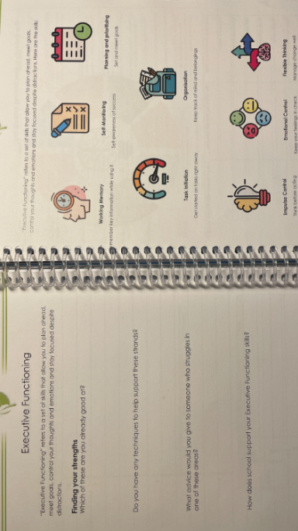
To support implementation of the approach, the project teachers developed pages for the staff handbook and student planner with clear explanations and examples of ways that executive functioning supports school life, and also included other resources that would be of practical benefit such as weekly planner pages, calendars with school events already entered and attendance streak trackers, which could be used during tutor time to encourage students to reflect on their executive functioning development.
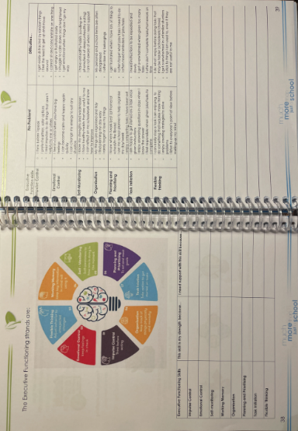
The planner also includes self-reflection tools linked to the planned programme of executive functioning lessons for KS3, supporting pupils to identify where they have executive functioning strengths and where there are areas in which they have more difficulty and need to work on developing skills.

Executive functioning lessons for students

The SEND and Inclusion team also developed a series of lessons for KS3 students, to be delivered through the school’s Social, Moral, Spiritual and Cultural education programme (SMSC lessons). The project teachers adapted these lesson resources and ensured that they were delivered to all students across Years 7-9. Each year group had a specific set of executive functioning themes in focus:

- Year 7
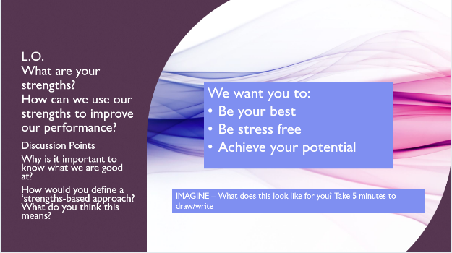
  - Emotional control
  - Impulse control
- Year 8
  - Flexible thinking
  - Working memory
- Year 9
  - Organisation
  - Planning and prioritisation
  - Task initiation
These lessons focused in each case on how these areas of executive functioning affected students, giving examples and scenarios for students to work through and helping them to identify strengths and areas for development. The deliverable resources were accompanied by task booklets. Teachers noted that students were more self-aware than they had initially expected, especially in the scenario-driven tasks.

Individual executive functioning intervention support for struggling students

Some students were identified by the school as needing more executive functioning support than the lessons delivered to all. HIAS SEN Advisers created and delivered a package of intervention designed to help students become aware of their areas of strength and difficulty in terms of executive functioning, and to develop effective strategies to cope with school life.

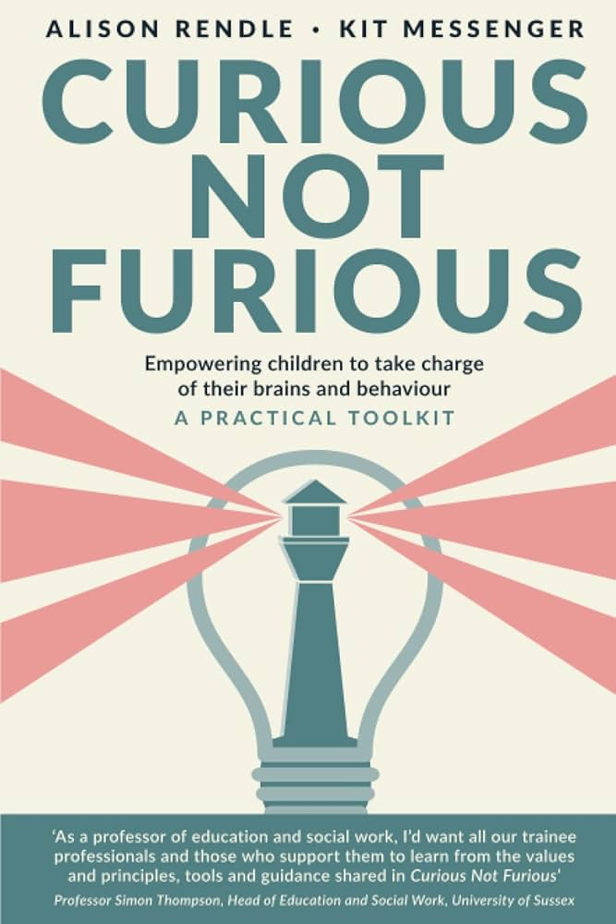
Initial session:
As a group, the Year 7 students were led through an activity focusing on exploring aspects of executive functioning and their own strengths and areas of challenge. The design of the activity was inspired by Curious, Not Furious by Kit Messenger and Alison Rendle (2023), who used animals in their books to characterise different aspects of executive functioning and help to make the concepts easy to grasp – for example, exploring the idea of emotional regulation by working out where the child sits on a continuum line between the “passionate and changeable” gorilla and the “cool and calm” swan. This activity helped the children to reflect on their executive functioning profile and identify areas where they needed strategies to help them manage more effectively in school, while also helping them also to see the strengths associated with their own profile.

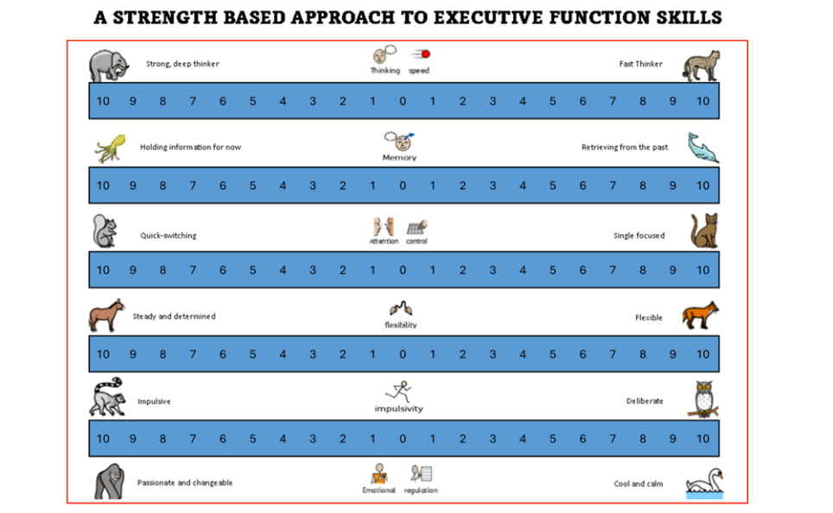
This strengths-based approach is fundamental to the supportive intervention that the students went on to receive one-to-one.

Support for parents and carers

The HIAS SEN Advisers also ran sessions for the parents and carers of students having intervention, explaining the process and inviting them to carry out the same activity to work out their own and their child’s executive functioning profile. This led to some very eye-opening reflections for parents and carers, meant that those children whose parents or carers attended these sessions were able to talk with their families in a more open way about their struggles in school and to negotiate with their parents around things that were important to them.

A number of parents and carers invited to these sessions were unable to attend and securing parental engagement was difficult in the case of some students. Where parents or carers were able to attend, the insights provided had the potential to have wider impact for the whole family, as some parents and carers were able to spot patterns and use strategies learned in the sessions with other siblings as well as the child involved in the intervention.

Individual intervention sessions

Students worked one-to-one with the HIAS SEN Advisers for eight sessions, using the initial profile to identify what they needed help with in developing their executive functioning. The anonymised case studies for the individual children show the bespoke support provided and the strikingly positive impact on their school lives.

Crucial to the success of the intervention was the follow-up in school to the recommendations that came out of individual sessions – provision of a safe space to calm down, a time out card, encouragement to attend a school club, material resources, and so on, were arranged by members of the school’s SEND team. Without this practical support and effective follow-through, the intervention sessions alone would have been useful but not as successful in making genuine changes to the students’ school lives.

While there was no deliberately gendered approach to the intervention – the focus of sessions was based on an evaluation of students’ individual needs and the strategies that would support them – the HIAS SEN Advisers found that there was something of a difference in emphasis between boys and girls. Boys within the one-to-one intervention programme tended to focus more closely on strategies that would support them with their school life in a practical way, such as the use of mind-mapping to support processing of information, task planning, use of the student planner to take control of issues around lateness and organisation, as well as developing self-awareness around the need for movement breaks and sensory feedback. Girls tended to focus more on personal organisation, emotional control, impulse control and self-regulation, particularly in terms of managing impulsivity and reactivity within friendship situations, and developing calming strategies. Girls also worked on strategies to support attendance to lessons rather than avoidance strategies.

In each case, tapping into the students’ interests and own priorities was important in securing engagement with the work during sessions. For example, a student whose specific interest was boxing, and who struggled to process information in texts shared during lessons practised using mind-mapping to organise information initially by making mind-maps focusing on boxing, and then learned to use the same strategy to make mind-maps of information from lessons.
What was the impact of the project at Park Community School?

Impact on students with intervention support

The students who were identified for the one-to-one intervention by the school were, at the beginning of the project, struggling significantly with a range of aspects of school life, often frustrated, quick to dysregulate and struggling to communicate their needs and advocate for themselves. The individual impact on students participating in the intervention was clear, with positive reflections from all the participating students as well as from staff working with them.

The supportive, personalised and practical approach has let to improvements in engagement with school, behaviour and attendance for these students, and the involvement of adults within the SEND team in follow up has meant that there is a sustainable approach established in school for these students beyond the end of the project

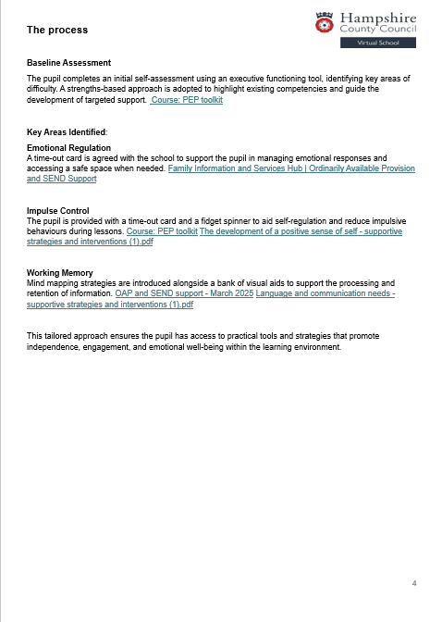
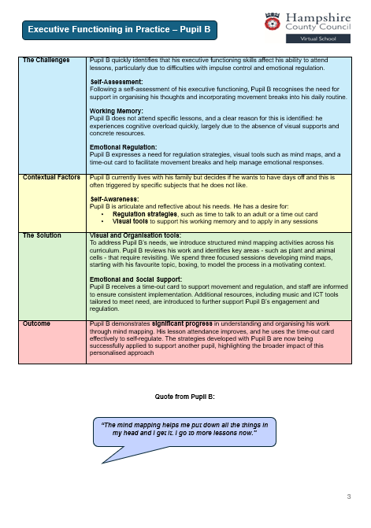
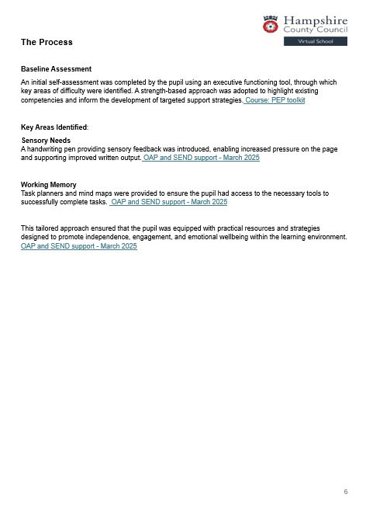
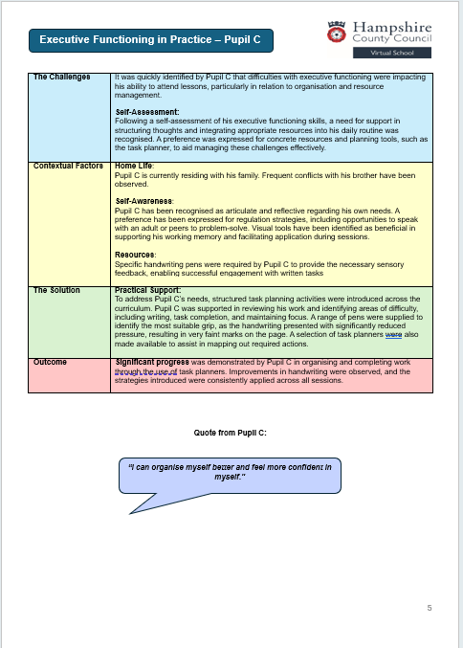
Anonymised case studies have been created to explain the impact of support in individual cases.

Student feedback:

“I go to the library and don’t skip lessons – I even go to maths. I feel more independent and more grown up… I have started to understand myself and why I do things. I enjoyed problem solving with my friends, you and my TA.”

“[I have gained skills in] mind-mapping, note taking and problem solving in the moment. I am better at organisation – check bag, organise pencil case and understand myself better…I am doing well in the tests but I don’t like them as much.”

“I am better at organisation and using the skills to support me. I use self-monitoring to support me in knowing what to do next.”

“[My favourite piece of work in the project was] talking through things so that I can make myself heard.”

“I have loved problem solving with someone who understands me… I am better at listening and talking to people. Reaching a compromise.”

“There is lots of noise in my head and this helps me calm down. They have helped with me regulating, problem solving, listening and reflect on what we need to do and how we can do it.”

Staff impact

The staff training delivered throughout the project was well received by teachers who felt that the approach included simple strategies for use in the classroom straightaway that would benefit all students, and agreed that the training would influence their practice. The project leaders felt that the project had made them more curious and aware of the potential impact of executive functioning issues within the classroom, and had helped them to anticipate the needs of students.

Student impact

Awareness of executive functioning and its impact on students’ ability to engage effectively has been written into the school’s expectations and is clearly visible within both the staff handbook and the student planners. It has been made part of the Overall Attitude to Learning self-assessment and teacher assessment that is reported to parents.

Executive functioning lessons are now part of the school’s SMSC lesson sequence and the executive functioning pages of the student planners are increasingly used during tutor times, particularly in Year 7, where the school has rewritten the curriculum and includes much more emphasis on executive functioning focused strategies.

Data evaluation

Due to the changeover of information management in Children’s Social Care at Hampshire County Council, data for Children in Need (part of the CWSW group) is not available for 2023-2024. We are therefore using comparison of Virtual School data between 2022-23 (before the beginning of the project) and 2024-25 (during and after the project) for impact evaluation purposes. We also have school data from Park Community School from 2023-24 and 2024-25, although this data does not include specific data for the CWSW group.

Attendance

Park Community School’s own data: year on year attendance improved between 2023-24 (the initial stages of the project were in the summer term, ready to launch across the next academic year) and 2024-25 by 1% across the school as a whole and by 3.7% in Year 7 in comparison with the previous year’s Year 7, with year on year improvements for all student groups tracked in Year 7 (SEN, Non-SEN, PP, Non-PP, boys, girls). Attendance also improved in Years 9 and 11. Across the school as a whole, all student groups’ attendance improved except for students with SEN, whose attendance dropped by -0.3%.

Virtual School data: early attendance indicators for the autumn term 2025-26 shows attendance by students identified as Child in Need has risen by 12.5% in comparison to autumn 2024-25, with unauthorised absence for this group falling by 3.8%. For students with a Child Protection Plan, attendance has risen by 6.5% and unauthorised absence has fallen by 5.2% to zero.

Suspensions

Park Community School data: incidences of suspensions (only ever issued for extreme disrespect, violence etc) reduced by almost half from 216 in 2023-24 to 112 in 2024-25. Suspensions for students eligible for Pupil Premium (PP) fell by 59% in comparison to non-PP students by 49%. Suspensions for girls fell by 67.3% in comparison to boys by 32.3%. Suspensions fell in all year groups except Year 8 by more than 50%.

Virtual School data: suspensions data for CWSW only exists fully for 2022-3 and 2024-5. Suspensions for CWSW accounted for 8.1% of total school suspensions in 2022-23 and for 8.9% of total school suspensions in 2024-25, and actual numbers of suspensions fell by 38.9% for CWSW in comparison to 44.3% for non-CWSW in 2024-25 in comparison with 2022-23.

As CWSW are significantly more likely to be suspended than other students, and there are far fewer of them, this suggests that the work that Park Community School has done to support these students is working well, with a stable percentage of a lower actual number of suspensions over time.

Separating out the data shows that Children with a Social Worker are not the exception to the school’s dramatic reduction in suspensions, despite their vulnerability.

Reduced hours provision:

Virtual School data: the proportion of CWSW accessing reduced hours provision has remained stable between 2022-23 and 2024-25, growing only very slightly from 11% in 2022-23 to 11.7% in 2024-25.

Behaviour incidents

Across KS3 in 2024-25, behaviour incidents in the category ‘disruptive behaviour’, which leads to a relocation to another room, fell by 14.6%. There were 91 fewer incidences of forgotten equipment recorded and 703 fewer recorded incidences of lateness to lessons in comparison with 2023-24.

Year 8: the exception year group:

Year 8 is the only year group where attendance has fallen, with particular falls in attendance for students with SEN and girls, and suspensions have risen, with a rise from 42 suspensions in 2023-24 to 44 suspensions in 2024-25 against a backdrop of dramatic falls in other year groups.

Overall evaluation of impact

Park Community School has made a range of changes to practice, including a significant overhaul of the Year 7 curriculum and work focusing on trauma-informed practice, across the same time period as the executive function project and therefore the impact of the project cannot be evaluated in isolation. However, the strength of the school is in making connections between development work and whole-school practice and seeing the approach as holistic.

Data for attendance, suspensions and behaviour logs strongly suggest that the work that has been done during this year, including work on executive function, has had a positive impact on the wellbeing of students across the school, with particular year-on-year gains in Year 7.

Increased staff understanding of the role of executive function in learning and the potential for delays in development of executive function as a response to neurodiversity, adverse childhood experiences and the stresses of living in poverty is now part of the whole school’s approach to both pastoral care and teaching and learning. The school’s CPD programme and staff briefing materials clearly refer to these aspects of development, enabling teachers to implement pro-executive function approaches as part of their ordinarily available provision.

What we learned from the project

This was a highly collaborative project, bringing together expertise from a range of different branches of Hampshire Children’s Services department and from across the school. Working together enabled us all to deepen our understanding of the intersection between support for the individual and practical approaches to having an impact across a wider range of students without making substantial workload demands on school staff.

We agreed that the most dramatic impact came at an individual level for the students supported through the one-to-one intervention, and that this process of support for students identified by the school as among the most vulnerable to social exclusion and disengagement from school has been highly valuable. However, the improvements in key metrics also suggest that the school’s evolving approach that includes explicit focus on improving executive function for all students across KS3 is having wider impact in a sustainable way.

Key takeaways

- Students are more self-aware than expected and can engage well with explicitly focused executive functioning lessons through the PSHE/SMSC curriculum or a tutor-time programme.
- Identifying the values held by staff as well as potential sources of resistance and using these to shape the CPD offer helps training to have traction.
- Principles of inclusive teaching are well placed to guide teachers to working in ways that are supportive of executive functioning development.
- Some students whose executive functioning development is delayed need much more in-depth, practical support through one-to-one intervention. Children With a Social Worker and students from other vulnerable groups would benefit from this support.
- The use of needs analysis before beginning intervention sessions is key. Once priorities are identified, one-to-one intervention sessions focusing on common-sense strategies to help students address these issues are straightforward to deliver.
- A small team of staff could take ownership of the one-to-one intervention programme within school – this role would sit well within the pastoral team or with Emotional Literacy Support Assistants (ELSAs).
- During one-to-one intervention sessions, tapping into the student’s interests is an important way into the skills and strategies that need to be delivered.
- Finding a connection with the student is important and finding the right person from the team to support the right student should be a priority, where there is choice available.
- Resources that might at first glance be perceived by adults as babyish for secondary students, such as the resources used in interventions where animals symbolise aspects of executive functioning, are in fact supportive of students’ developing understanding of their own behaviours and development needs without feelings of shame.
- Practical follow-up on recommendations coming out of intervention sessions is a crucial element of the support for one-to-one supported students. Providing opportunities to build upon strengths is part of this.
- While it is not always possible to identify which students have or have had involvement with social services, pro-executive functioning strategies appear to have a positive impact across the board and are well-placed as an element of school’s ordinarily available provision to support these students without adding to teachers’ workload.

Ming H, Zhang F, Jiang Y, Ren Y, Huang S. Family socio-economic status and children's executive function: The moderating effects of parental subjective socio-economic status and children's subjective social mobility. Br J Psychol. 2021 Aug;112(3):720-740. doi: 10.1111/bjop.12490. Epub 2021 Jan 9. PMID: 33421109.
Russell Barkley, PhD ADHD and Children's Delayed Executive Functioning Age - Part 1, accessed 26/11/25
Barrett KK (2018) ADHD and the Case for Support through Collegiate Age: Understanding the Lifecycle of Developmental Delays in Executive Function for ADHD and its Impact on Goal Setting. J Child Dev Disord. Vol.4 No.3:11, https://childhood-developmental-disorders.imedpub.com/articles/adhd-and-the-case-for-support-through-collegiate-age-understanding-the-lifecycle-of-developmental-delays-in-executive-function-for.pdf, accessed 26/11/25
Cameron Hecht, Christopher J Bryan and David S Yeager, A values-aligned intervention fosters growth mindset–supportive teaching and reduces inequality in educational outcomes, 2023. Downloaded from https://www.pnas.org by 208.127.48.138 on June 26, 2023 from IP address 208.127.48.138

