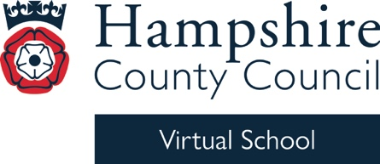


Virtual School Update 1

Dear Designated Teacher and Lead

Welcome back, and I hope you had a great summer, although I imagine it already feels like a distant memory!

This is the first Virtual School Update email of the year, and there’s a lot of information below and in the attachment, including a reminder about our EP consultations and PLAC training, as well as details about Kinship Care Week and #BeeWell.

As well as this email, we have sent a newsletter via School Communications for a wider audience, containing key information about the Virtual School. It’s attached in case you missed it.

We are getting very excited about our DT conference on Thursday 5 November, featuring our two excellent keynote speakers. If you haven’t booked yet, please follow the link: Designated Teacher Conference Autumn 2026 Tickets, Thursday, November 5 • 9 AM - 4 PM | Eventbrite.

Please note that there is a charge for the conference, but we guarantee it will be a brilliant day!

We are also running our PLAC and the School Census 2026 training on Thursday 10 September, Monday 14 September and Tuesday 15 September. If it is too late to book via Eventbrite, or if it shows ‘sales closed’ and you would still like to attend, please email the team at virtualschool@hants.gov.uk, and they will book you on. It is essential that PLAC children are included in the October census. Otherwise, you will not receive pupil premium funding for them.

For all Virtual School training for 2026/27, please see our training brochure. We have new sessions this year on ‘Empowering Teachers and Schools: Supporting Executive Functioning’. Additionally, we have short PEP webinars available throughout the year in the PEP section of our Moodle site.

Lastly, the PEP deadline this term is 27 November. Please ensure your PEP meetings are booked in. If you have any problems, please contact hcc.peps@hants.gov.uk.

Virtual School EP consultations

Our Virtual School EP will continue to hold weekly consultations throughout the year. These can be booked for children in care, previously looked-after children (PLAC), children with a social worker (CWSW) and those in kinship care. Details of how to book a one-hour consultation can be found here.

What is an Educational Psychologist (EP)? EPs work to support children and young people in education settings to reach their full potential by working with them and the key adults who support them. They draw on a range of psychological theories in their work, and the underpinning ethos involves looking at the environment around the child.

What is a consultation? A consultation is a problem-solving space where key adults in a child’s life meet with an EP to discuss their strengths, needs and aspirations. During the consultation, the group will work together to understand the child’s situation and whether this can be moved forward in any way.

Consultation with the Virtual School EP is not:

- part of an education, health and care needs assessment
- part of a diagnostic pathway for disorders such as ADHD and ASD
- a pathway to an in-depth EP assessment and school visit
- linked to the Hampshire Educational Psychology team

For further information on how to access any of the above, please speak to your school’s SENDCo.

Who can come? Important adults in the child’s life, such as parents/carers, teachers and other school staff, social care staff, Virtual School staff and other relevant adults and professionals. The child may also want to join the meeting to share their views.

Kinship Care Week

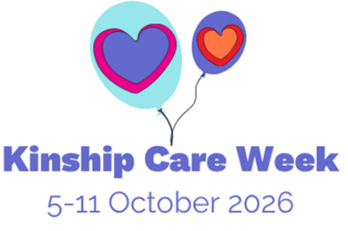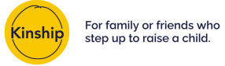
Kinship Care Week (5-11 October) is a national week of awareness, recognition and celebration of kinship families across England and Wales.

Kinship is the leading kinship care charity in England and Wales, providing information, advice and support to kinship carers – friends or family who step up to raise a child when their parents aren’t able to.

This Kinship Care Week, we’re celebrating the unbreakable bonds at the heart of kinship families – and the communities they build to support one another – while highlighting the realities of stepping up to care for a child who has had a difficult start in life.

You can find out more and get involved by visiting: kinship.org.uk/kinship-care-week and accessing the Kinship Care Week digital toolkit.

If you hold any events for Kinship Care Week, or have any questions regarding kinship care, please get in touch – VSExtendedDuties@hants.gov.uk.

Training

PLAC and the School Census 2026: What You Need to Know, online training.

10 September 2026, 3.45pm to 4.45pm.

Click here to book.

PLAC and the School Census 2026: What You Need to Know, online training.

14 September 2026, 10am to 11am.

Click here to book.

PLAC and the School Census 2026: What You Need to Know, online training.

15 September 2026, 2pm to 3pm.

Click here to book.

#BeeWell programme

Good news! #BeeWell school recruitment has been extended until Friday 11 September 2026, giving schools one final opportunity to sign up and take part in this year's survey.

#BeeWell is a youth-centred wellbeing programme working with secondary schools to deliver an annual pupil wellbeing survey. Over the last three years, we have worked with 115 secondary schools, hearing from more than 63,000 pupils across Hampshire, Isle of Wight, Portsmouth and Southampton (HIPS).

We are now inviting all secondary schools in Hampshire to join the programme and ensure their pupils’ voices help shape action to improve young people’s wellbeing locally. Sixty-four secondary schools in Hampshire have already signed up to take part this autumn, and we would be delighted to welcome more schools to the programme.

Our school recruitment is open until Friday 11 September 2026. To take part, sign up here: Expression of Interest (sign-up) form

What your school will receive:

- continued 1:1 support throughout the entire survey process, from signing up onwards, including additional support such as short and symbol surveys for non-mainstream settings
- a tailored insights report and data dashboard interpreting your school level data, with support from data specialists
- student voice opportunities through youth-led activities, including a wellbeing podcast and the #BeeWell Youth Steering Group

Knowledge development:

- support sessions and workshops on engaging pupils and parents, as well as area-level workshops for professionals from our partner, Mental Health Charity | Anna Freud
- access to professional development opportunities such as funded projects, train-the-trainer courses and access to further wellbeing initiatives

To find out more about what we do, you can explore:

· headline findings from our latest survey
· school case studies showing how others are using their data
· the HIPS Neighbourhood Dashboard, which shares anonymised local-area insights

We would be delighted to see your school taking part in #BeeWell this year. If you need more information or have any queries, please email the HIPS #BeeWell team at HIOW.BeeWell@hants.gov.uk.

Kind regards
Michelle

Michelle Nye
Virtual School Head
Hampshire Virtual School

h1 example

h2 example

h3 example

h4 example

Some example “normal” copy.

“A pull-out quote will look like this”

