Why do we celebrate Mother’s Day?
In News FSF on Monday at 19:14
Mother’s Day is coming up this weekend, and in settings and schools there may be a focus on Mummies. Perhaps cards will be made, or paper flowers, and perhaps there will be lots of conversations about what our Mummies do for us and why we love them.
As part of our reflective practice, we often think about why we’re doing what we’re doing. Why do we store the wooden blocks next to the small world animals? Why do we have a rolling snack time? Why do we do register time like this? Asking ‘why’ helps us to focus – is this supporting children’s learning and development, are we providing for every child, do we need to do it this way, can we do it differently (and better)?
So, why do we celebrate Mother’s Day?
As with so many things that we do, the answer might be ‘because we always have’. Or perhaps ‘because it helps children to learn about love and saying thank you to their Mummies who look after them’?
Let’s dig a little deeper.
Thinking about being loved, and loving, helps children remember they are kept in mind, they have people who care about them, and to learn ways to show their own love. For many children, this will include their Mummy.
But we can, and do, support children to recognise love and kindness in others and in themselves all the time. In those small, meaningful moments in their day, when we and they can be responsive to a feeling or thought. Perhaps in one of those moments they may choose to make a card, or something else, or use their words, body language, or actions. When this experience has been prompted by the child, or led by a book you are reading together, or by a question you ask, on any day of the year, the learning will be deeper.
Because for many children, Mother’s Day may be a trigger.
There are so many different versions of family and so many family stories.
A child may live with their single Dad or have two Daddies.
There may be a child who is living with their foster family.
Or a child’s Mummy may have died, or perhaps their Mummy’s Mum – their Granny – has passed away and this is a painful time for the whole family.
Perhaps an older sibling is a child carer, looking after everyone in the home. Or there may not be the caring relationships at home that we would hope every child would experience, but we know do not.
These are only a few of the reasons why Mother’s Day is not relevant to every child, and why it might trigger feelings, and perhaps behaviour.
There are also the families at home, who might find Mother’s Day particularly challenging. I know from the experience in my own family, and that of my friends’, that the death of a child can be part of a family story. And we might not always know – for example if a baby was still born or a baby has been lost through a miscarriage. Mother’s Day can be a very sad time for Mummies.
For all these reasons, and more, perhaps we can recognise that Mother’s Day doesn’t provide for and support the learning and development of every child, and that we can learn together about giving and receiving love and kindness and being grateful in so many other meaningful ways, every day.

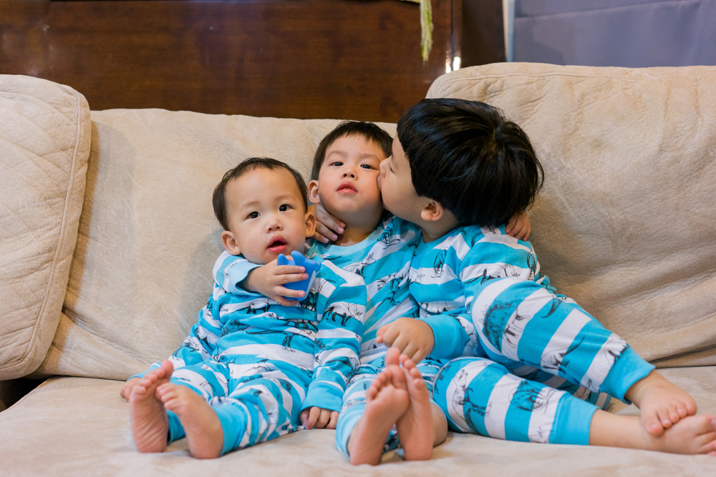
March 2021 Foundation stage forum EYFS info

