Transition Partnership Agreement (TPA): Supporting Transition from Early Years Settings
  Child’s Photo | Child’s name:
 | Date of birth:
 | Child’s parent(s)/carer(s):
 | Current setting:
 | Transitioning to:
 | Date of TPA meeting:
 | Present at meeting:
 | Background information – my journey so far
 | This could include key information such as relevant medical details, settings attended, other agencies involved, key adults that are important etc.
 | Strength and interests
 | What do I like doing? When am I happiest? What are my character strengths? What is important to me?
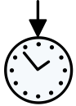 | Now
 | What am I working on? What do I need help or support with?
 | What’s helping?
 | What approaches or strategies work well?
 |  | What’s unhelpful?
 |  | Is there anything getting in the way, environmental factors, barriers in the setting etc?
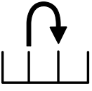 | Next steps
By the end of the EYFS, I will ….
I will be able to communicate my needs and wants using spoken words, signs, symbols or other visual cue

By Spring half term, I will ….

By Autumn half term, I will….

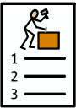 | Agreed actions
 | What, who, where, and when?

Signatories | Designation | Date
Person completing this form
Present setting manager
Future setting manager/ head teacher/SENCo
Parents/Carers
 | Review
 | When, with who?

